Creating Accessible Word Documents

Instructions
Making a word document accessible involves being aware of some common accessibility concerns that we sometimes see in the documents. Listed below are the 10 most commons concerns we occasionally see in Word documents. We have broken these areas into 10 steps “TRY IT”. We first explain how to perform a specific task and then below the explanation we will have you perform the task to make a specific item accessible.
Once you have finished making the corrections to the 10 Try It areas, rename your document Creating_Accessible_YourLastName and submit it under the Final Project assignment.

Microsoft Office Note:
These directions are created for Microsoft Word 2016. Please know the newest version of Word is available for you to download through Office 365, this version has the accessibility checker built into it. All SCF employees and students may download five copies of Microsoft Office for free.
Directions for downloading Microsoft Office (Contact IT Help Desk for more information)
Mac Users: The directions in this exercise reference PC. However, detailed instructions for Mac can be found on the Microsoft Accessibility site. Also, please review how to use the Accessibility Checker on your Mac to find and resolve accessibility issues.

Try It #1: Explanation – How to use the Accessibility Checker
In this step we show you how to use the accessibility checker in Word.

Use the Accessibility Checker
Accessibility Checker Microsoft Video Tutorial
- Select the File tab from the Ribbon
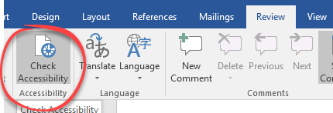
- Select Info from the left menu
- Select the Check Issues button, and then Check Accessibility
- The Accessibility Checker task pane appears to the right.
- View the Inspection Results
Newer versions of Word will have the Accessibility checker on the Review Tab.

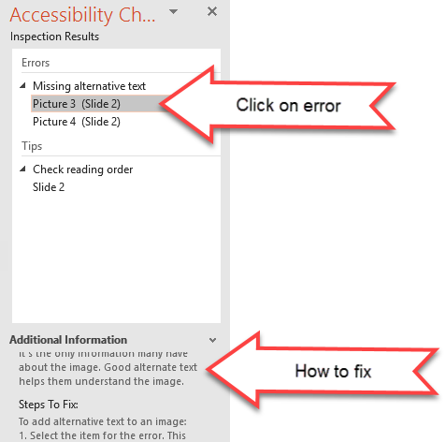
Use the Results
The report will list errors and tips. If you click on the error, the information describing how to correct the problem will be displayed at the bottom. Tips will also describe related best practices.
Mac Users: Please know the newest version of Word is available for you to download through Office 365 (Contact IT Help Desk for more information), this version has the accessibility checker built into it. More information can be found on the Microsoft site (Use the Accessibility Checker on your Mac to find and resolve accessibility issues).

Try It #1: Now it is your turn to perform this function
Following the steps above run the accessibility checker on this document (you do not have to fix anything just demonstrate that you know how to use the tool) and answer this question;What Accessibility errors does this document have? Describe the error below or paste a screenshot of the Inspection Results below (make sure to add alt text) if you paste an image.

Try It #2: Explanation – How to use Headings
In this step we show you how to apply headings to a document.

Layout Tutorial Section
The document should be formatted using a hierarchy of styles (Heading 1, Heading 2, etc.). Headings should be used to indicate a change of topic. Heading levels should not be skipped.

Format Heading Structure
Heading Structure Microsoft Video Tutorial
- Highlight the text you need to format
- On the Home tab, select the appropriate Style (Heading 1, Heading 2, Normal, etc.)

Remove Formatting
If you need to remove formatting from text:
- Highlight the text you need to remove the format
- Select the “Clear All Formatting” icon located in the Font section of the Home tab.

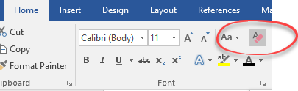

Try It #2: Now it is your turn to perform this function
Below is a sample that demonstrates how Headings are typically used in Word documents and in Canvas. Please apply the appropriate heading for each heading as designated in the parenthesis at the beginning of each sample.

(STYLE: Heading 1) Example of Organization with Styles: Heading 1 is the Top Level of a Structured Document

(Style: Heading 2) Introduces Tabular Data
(Style: Normal) Here is some information about another category that actually needs to be subdivided in order to clarify its three points.
(Style: Heading 3) The First Point about Table 1
(Style: Normal) Supportive text explains this point. It goes on about why this is true. It also explains why this is important.
(Style: Heading 3) The Second Point about Table 1
(Style: Normal) Supportive text explains this point. It goes on about why this is true. It also explains why.
(Style: Heading 4) A subsection of my Second Point
(Style: Heading 4) Another subsection of my Second Point

Try It#3: Explanation – How to add Alt Text

Alternative Text Tutorial Section
Add alternative (Alt) text that is a succinct and concise description of content or function to:
- Images
- Charts
- Shapes
- Tables
Decorative images that do not convey unique content, should have a double quote (“”) for the description. This communicates to the screen reader to skip the image. Do not use “This is an image of…” in the description. Screen Readers announce the type of content, such as “image” or “chart”.

Alt Text Microsoft Video Tutorial

- Right-click the image and select Format picture.
- In the Format Picture pane, select the Size and Properties icon and then choose Alt Text.
- In the Description text box, type the alt text for the image.

Try It#3: Now it is your turn to perform this function
Follow the steps above to add Alt Text to the image below.
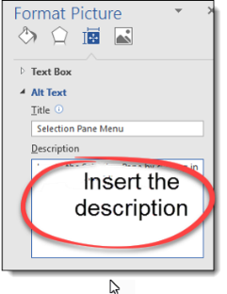

Try It #4: Explanation – How to add Alt Text to a Chart

Adding Alternative Text to Charts Tutorial Section
- On the Chart’s border, right click
- From the menu that appears, select Format Chart Area
- On the Format Chart Area pane, select the Size and Properties icon and then Alt Text
- In the Description window, add the descriptive narrative text
- Select the Close button

Try It#4: Now it is your turn to perform this function
Follow the steps above to add Alt Text to the chart below.

Try It #5: Explanation – How to make a table from the Data

Make a table from the data Tutorial Section
If the chart contains complex data, you can include the data table, rather than explaining in the description. You can copy the data associated with the chart by following the steps below.

- Right click on the chart.
- Click Edit Data.
- Then Edit Data in Excel.
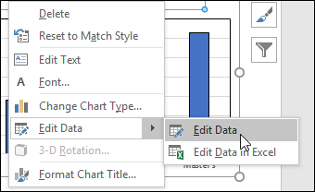
- Copy the data from the table and paste on the document.

Try It #5: Now it is your turn to perform this function
Follow the steps above to copy and paste the data from the table below.

Try It #6: Explanation – How to add Alt Text to a Table

Add Alternative Text to Tables Tutorial Section
- Right click on the table.
- From the menu, select Table Properties
- On the Format Table Properties pane, select the Alt Text tab, and enter the description in the description box.

Try It #6: Now it is your turn to perform this function
Follow the steps above and in the Description box, add the descriptive narrative text: “A list of assignments along with the point values” to the table below.
Assignment | Points
Paper One | 100
Paper Two | 100
Quiz One | 100
Mid-Term Exam | 100

Try It #7: Explanation – How to add a Header Row to a Table

Define a Clear Table Structure Tutorial Section
Tables should have a simple structure with column headers. Avoid blank cells, merged cells, and nesting tables.
Accessible Tables Microsoft Video Tutorial
- Position the cursor anywhere in a table.
- On the Table Tools Design tab, in the Table Style Options group, select the Header Row check box.
- Type column headings.
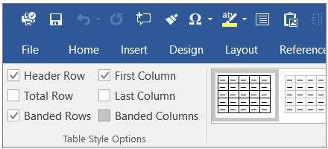

Try It #7: Now it is your turn to perform this function
Follow the steps above to create a header row for the data table below.

Education Level | Income
HS | $28,000
Associate's | $35,000
Bachelor's | $52,000
Master's | $63,000

Try It #8: Explanation – How to create descriptive Hyperlinks

Create Meaningful Hyperlinks Tutorial Section
Hyperlinks should describe the destination, not list the URL. Links should not use non-descriptive text such as “link”, “click here” or “Read more….”.

Incorrect: To learn more about SCF please visit http://scf.edu/.
Incorrect: To learn more about SCF please click here.
Correct: To learn more about SCF please visit SCF Homepage.

Meaningful Hyperlinks Microsoft Video Tutorial
- Select the descriptive text that you want to use for the hyperlink
- Right-click the text
- From the Insert Hyperlink menu, type the web address in the Address: window
- Select OK

Try It #8: Now it is your turn to perform this function
Follow the steps above to add a descriptive hyperlink to the sample text below using the URL:
https://www.hhs.gov/web/section-508/making-files-accessible/checklist/word/index.html

Create a link to sentence to the right using the URL directly above this sentence for this Text: Word Document 508 Checklist

Try It #9: Explanation – How to change color

Color Tutorial Section
Sufficient contrast is provided and color is not used solely to convey important information. Check your color contrast

Avoid
- Green & Red
- Green & Brown
- Blue & Purple
- Green & Blue
- Blue & Grey
- Green & Grey
- Green & Black
- Light Green & Yellow

To change the fill color:
- Select the text box you want to change.
- On the Format tab, click the Shape Fill drop-down arrow. The Shape Fill menu will appear.
- Select the color you want to use. To view more color options, select More Fill Colors. ...
- The text box will appear in the selected fill color.

To change the text color:
- Highlight the text and choose the appropriate color
Or
- Select the text box you want to change.
- On the Format tab, click the Text Fill drop-down arrow. The Text Fill menu will appear.
- Select the color you want to use. To view more color options, select More Fill Colors.
- The text will appear in the selected fill color.

Try It #9: Now it is your turn to perform this function

Change the colors of this textbox below to improve contrast by making the text black and removing the box fill (No Fill).

1.4.3 Contrast (Minimum): The visual presentation of text and images of text has a contrast ratio of at least 4.5:1, except for the following: (Level AA)

Try It #10: Explanation – How to choose an accessible YouTube Video

Search for Captioned YouTube Videos Section
YouTube allows closed captions to be added to videos by the owner. For more information on how to add captions to your videos in YouTube, review this webpage on Adding Closed Captions on YouTube.com. YouTube automatically creates auto-captions for uploaded videos as well. However, these captions do not meet accuracy standards.
You can save a lot of time by selecting accessible videos that have accurate closed-captions.
To search in YouTube for accurate closed-captions:
- In the YouTube search window, add "cc" to your search.
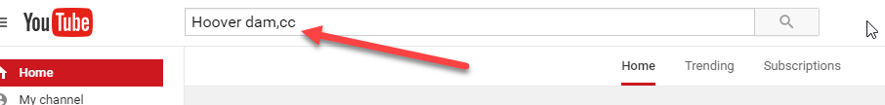
- This will filter your results to just list videos with closed-captions.
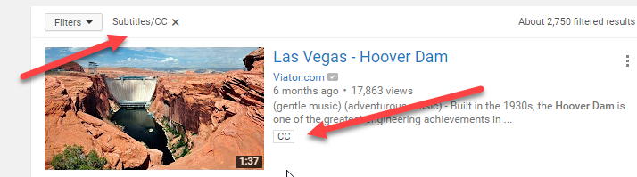

Try It #10: Now it is your turn to perform this function
Go to YouTube and find an accurate closed caption video (not auto-generated) and paste the link below (remember to use a descriptive hyperlink).

Works Cited
"Learn to Create More Accessible Word Documents." Learn to Create More Accessible Word Documents - Office Support. Microsoft Office, n.d. Web. 10 May 2017. <https://support.office.com/en-us/article/Learn-to-create-more-accessible-Word-documents-0b2ca649-69a5-4d3b-9ff5-a56e6611d194?ui=en-US&rs=en-US&ad=US>.
"Make Your Word Documents Accessible." Office Support. Microsoft Office, n.d. Web. 10 May 2017. <https://support.office.com/en-US/article/Make-your-Word-documents-accessible-D9BF3683-87AC-47EA-B91A-78DCACB3C66D>.
"Microsoft WordCreating Accessible Documents." WebAIM - Web Accessibility In Mind. Web AIM, n.d. Web. 10 May 2017. <http://webaim.org/techniques/word/>.
Secretary, HHS Office of the, and Digital Communications Division (DCD). "Word Document 508 Checklist." HHS.gov. US Department of Health and Human Services, 05 Jan. 2015. Web. 10 May 2017. <https://www.hhs.gov/web/section-508/making-files-accessible/checklist/word/index.html>.

