3.4 Graphs of Polynomial Functions
Consider the graphs of odd polynomial functions such as:
- $f\left(x\right)=x$

- $f\left(x\right)=x^{3}$

- $f\left(x\right)=x^{5}$
Now consider the graphs of even polynomial functions such as:
- $f\left(x\right)=x^{2}$

- $f\left(x\right)=x^{4}$

- $f\left(x\right)=x^{6}$
Pay attention to the end behavior (far left and far right). Notice that all even powers are the same and all odd powers are the same. This knowledge will help us determine what the graphs of polynomial functions look like at the ends (domain elements near $-∞$ and $+∞$). Of course the above may be reflected across the $x$-axis. Do you remember how to do that?
Suggested strategy for graphing polynomial functions:
- Determine any real $x$-intercepts and their multiplicities. Whatever the multiplicity is, the graph will look like that function near the $x$-intercept.
  - First powers look like lines
  - Second powers look like parabolas
  - Third powers “wiggle” like the cube function, etc.
  - Higher even powers look like 2nd powers. 4th, 6th, …
  - Higher odd powers look like 3rd powers. 5th, 7th, …
- Determine the $y$-intercept
- Look at the degree (highest power) to determine the end behavior. Be careful of negative coefficients, they will reflect the graph across the $x$-axis.
- All polynomial functions are continuous. So now all you need to do is connect the dots.
Practice:
Graph $f\left(x\right)=-(x+2)^{4}+3$

Graph $y=\frac{1}{24}(x+3)^{2}(x+1)(x-2)^{3}$

Graph $y=-\frac{1}{4}(x+2)(x-2)(x-5)$

Turning Points Theorem: The graph of a polynomial function with degree $n$ has at most $n-1$ turning points.
Definition: A turning point is a point in which the function is increasing or decreasing on the left and doing the opposite on the right. In other words, a point where the function goes from increasing to decreasing or from decreasing to increasing.
We will not prove this theorem as it requires calculus. However, it can be useful in matching graphs to functions. Note that this tells you the maximum number of turning points, not the exact number there are. For example, a 5th degree polynomial could have 4, 3, 2, 1, or 0 turning points. However, it could not have 5 or more.

Graph $f\left(x\right)=-x^{4}-3x^{3}+3x^{2}+11x+6$ and write the polynomial in factored form given that $k=-1$ is a zero. Note that for a question such as this, it is implied that you start with your calculator to find zeros or are given at least one zero. This would be too difficult to do by hand.

Write a polynomial function that will produce the graph below. Hint: Think about $x$-intercepts and their multiplicities, end behavior, and be very careful about the $y$-intercept and the necessary scaling coefficient including whether it is positive or negative.
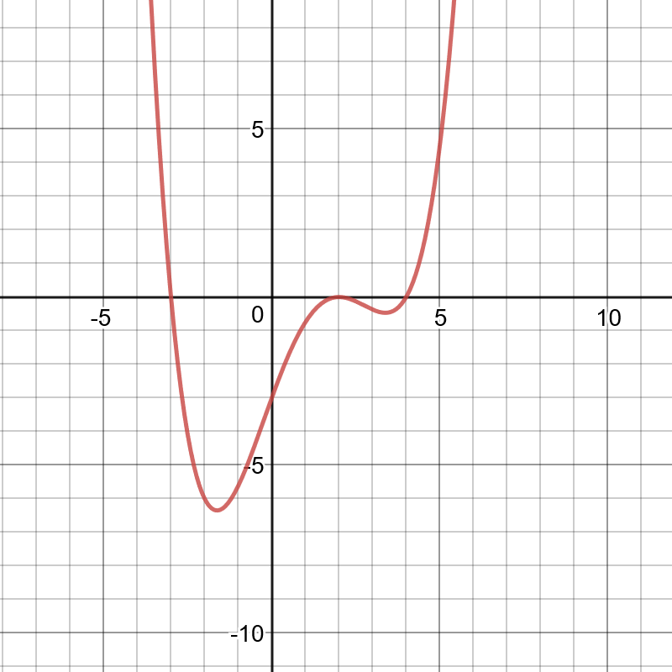

Do the same for this graph.
